# Assignment – Sidebar (HTML + CSS)

In this assignment you will be implementing a static sidebar with plain HTML and CSS which would look something like this 👇🏻

## 

## Specification Checklist

**NOTE - All the absolute units should be converted to relative (rem) units, except in case of borders. 1rem = 16px by default.**

### Body

* The font used is sans-serif
* The font is used document wide, but should it fail to render in any case, the fallback fonts should be rendered.

### Container

* The sidebar should have a border on three sides i.e. top, right, and bottom. There is NO border on the left
* The border should be rounded on three sides (mentioned above) ONLY! Which means the top-left and bottom-left corner should not be rounded.
* The border color is of 1px, solid style, and color #dadada
* The sidebar heading should be transformed to uppercase.
* There should be a margin on 1rem
* A padding of 2rem should be applied in Y direction (top & bottom), No padding in the X direction (left & right)
* A width of 10rem and a height = 80% of the viewport height.

### Heading

* Should be colored blueviolet.
* A padding of 0.5rem in the X direction. No padding in Y direction.
* Size of the font should be 12px
* The text should be converted to all UPPERCASE with a spacing of 2px in between

### Item

* A padding of 0.5 rem all around the content.
* Each item should be separated by a distance of 4px.
* On hover the font should turn semi-bold (with weight of 600) and the background color to #f0f0f0
* The cursor should turn into a pointer when the mouse is on this item.

## Guidelines

Below are some hints given on how to style the sidebar effectively without writing redundant code. With these guidelines you shall be able to create a neat styling sheet for your sidebar.

* The starter HTML code is given in the Appendix and it should only be modified where indicated and nowhere else.

## Appendix

<!DOCTYPE html>

<html>

<head>

<title>Sidebar</title>

<!-- Add font link here -->

<!-- Add stylesheet link here -->

</head>

<body>

<aside class="sidebar">

<h3 id="sb-heading">Workspace</h3>

<div class="sb-item">Home</div>

<div class="sb-item">Dashboard</div>

<div class="sb-item">Analytics</div>

<div class="sb-item">Profile</div>

</aside>

</body>

</html>

## References

#### Before (Without CSS)

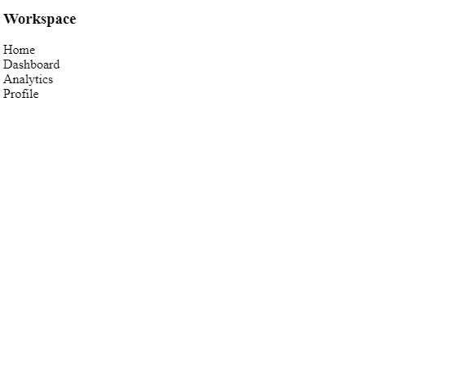

#### After (With CSS)

